**CSS3 Evidence Questions**

1. Create the following web template with logo, top menu, left menu and a search Box.
2. Create a External CSS file and link with the page.

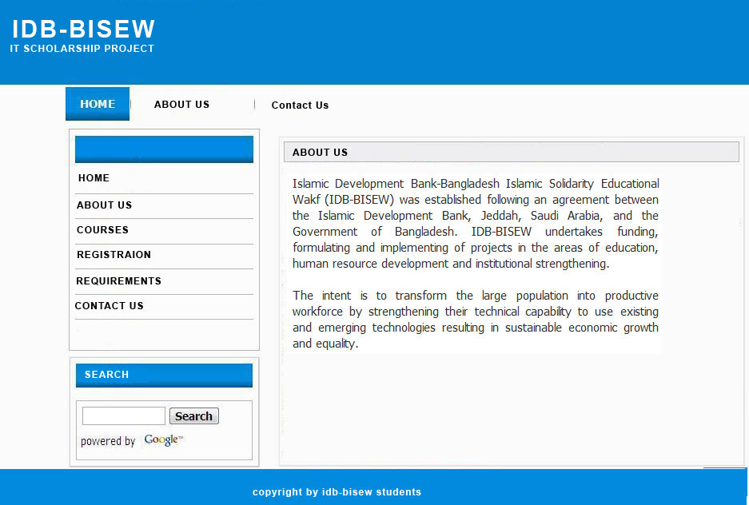

1. **Create the following Contact form with necessary field and link with the top and left menu.**

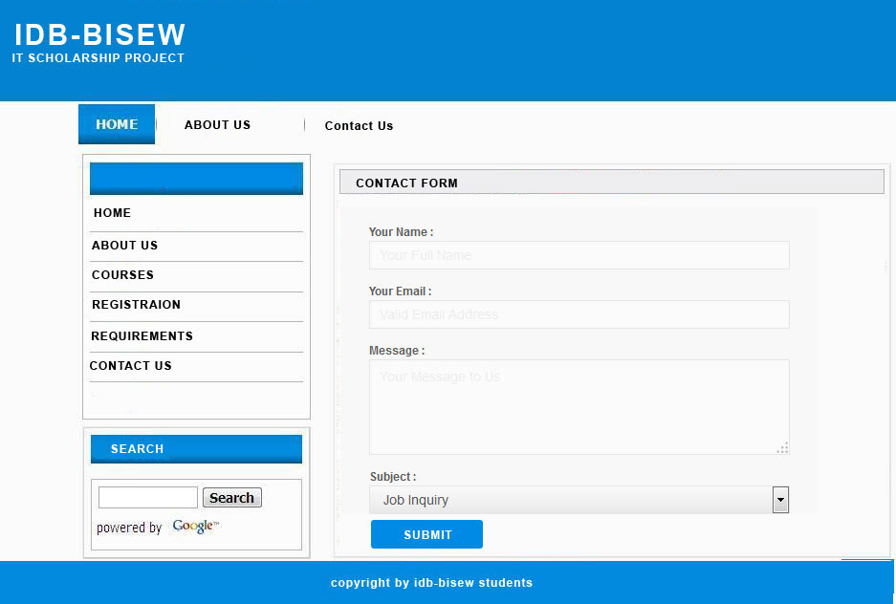

1. **Create the following Courses list with necessary information and link with the top and left menu.**

